AER Hardware and cabling
This document describes the cabling and protocol for the AER boards.
The hardware is receives and sends word-parallel point to point or multisender AER, using active low request and acknowledge signals.
There is a USB device connector and two functionally equivalent AER connectors: a CAVIAR standard 40 pin 100mil double row header and a Rome 20 pin connector. The pin assignments on the CAVIAR connector are specified in the CAVIAR document “Consortiumstandards.pdf” in the repository folder CAVIAR/wp7 and are repeated here for reference:
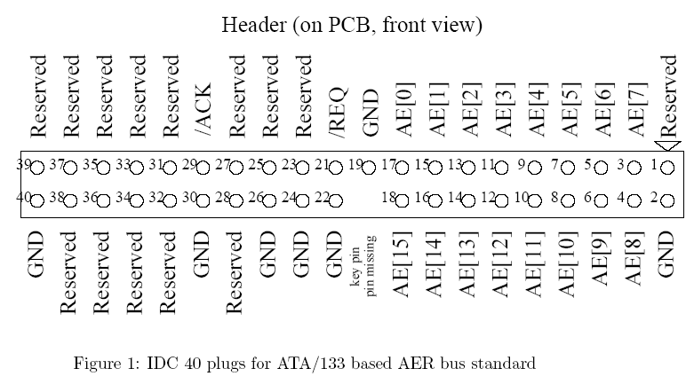

The other connector on the board is a 20 pin SCX Rome PCI-AER connector on it. That cabling follows
